Test 0

Terminate the application

select choice 0 and msg should be shown.

Test 1-0

Create a story with description

a story is created and shows process successful

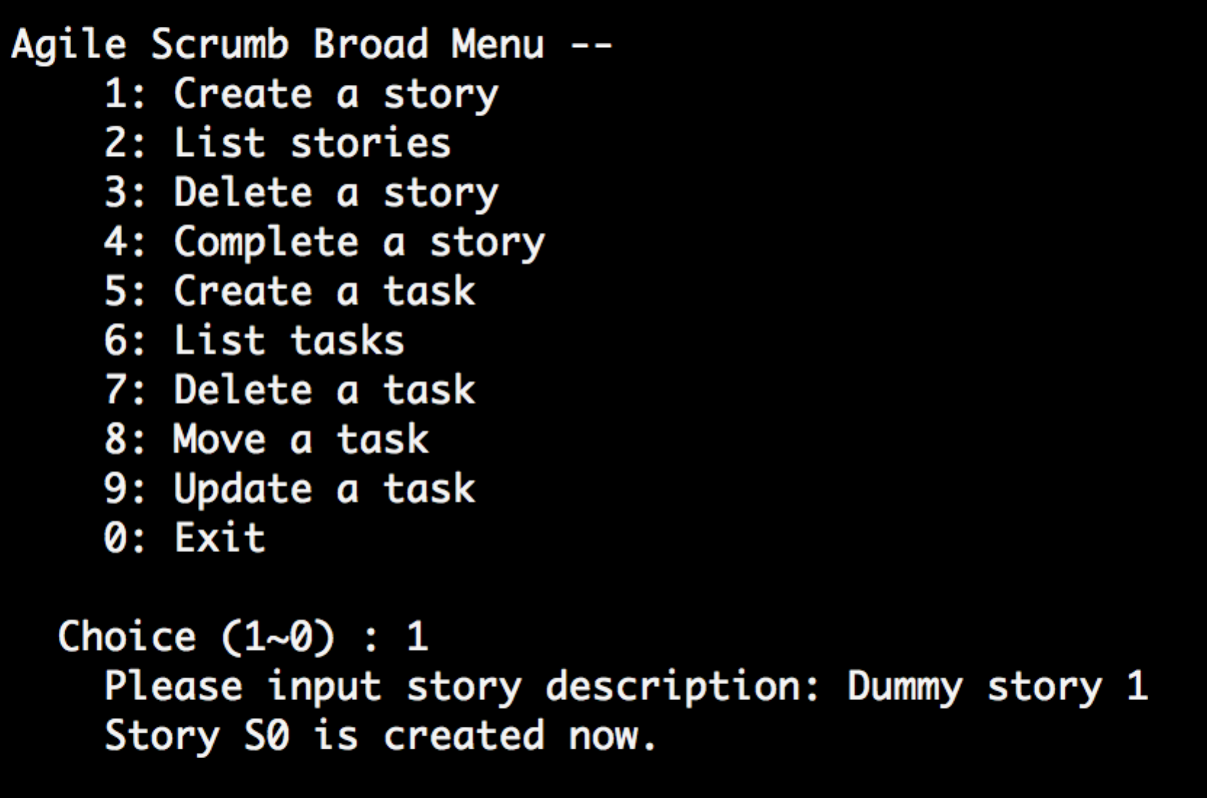

Test 2-0

List all stories when there is at least one story

Stories are shown.

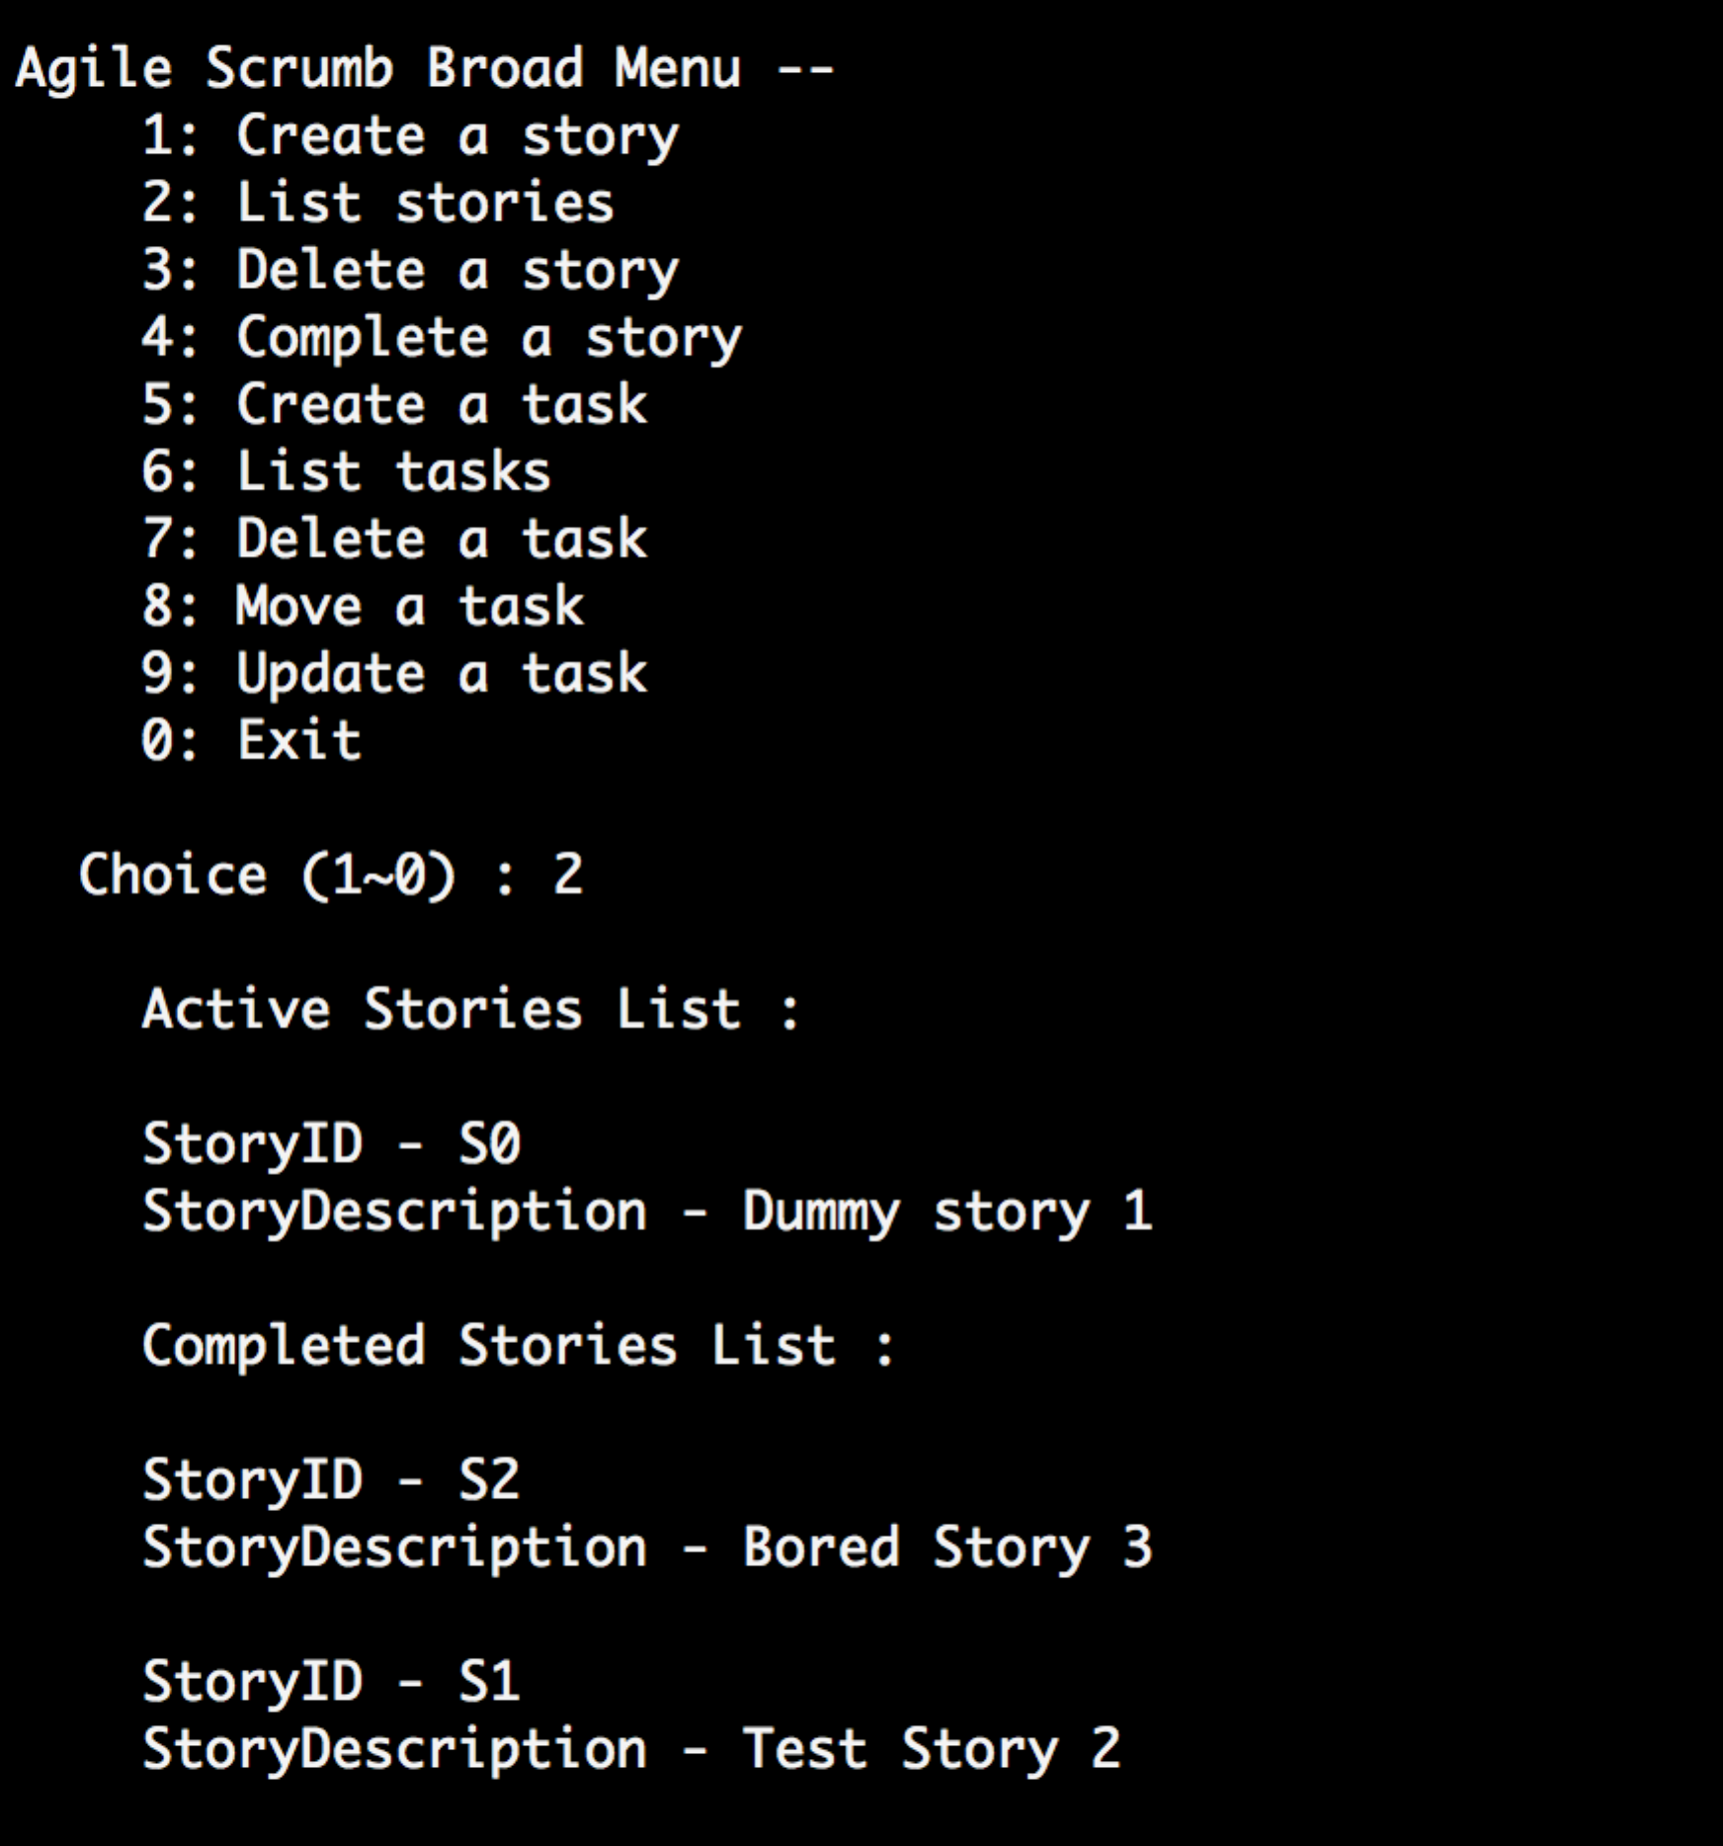

Test 3-0

Delete an active story

The story is deleted and msg shows

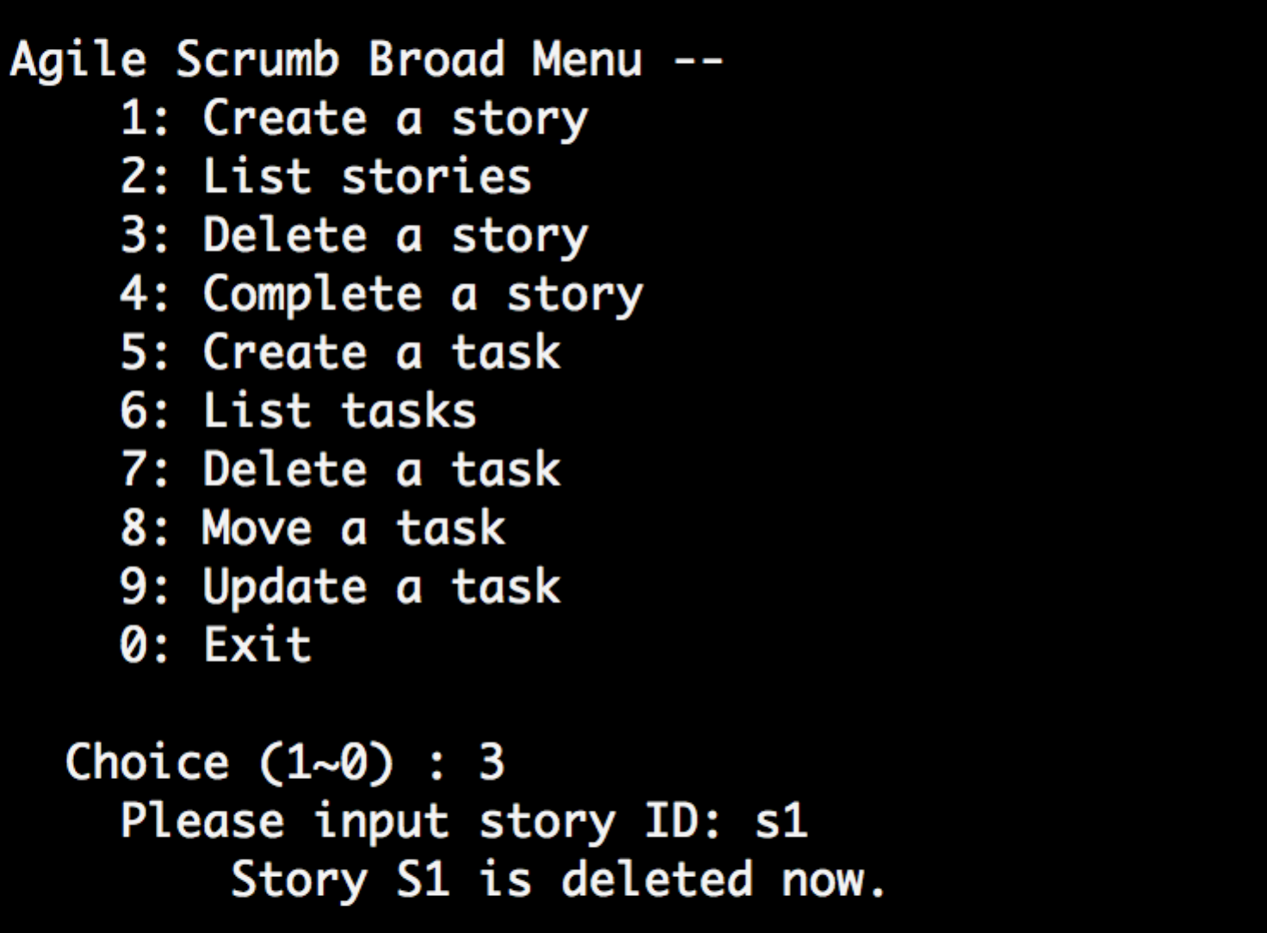

Test 3-1

Delete a non-exist story

Shows error msg "story not found"

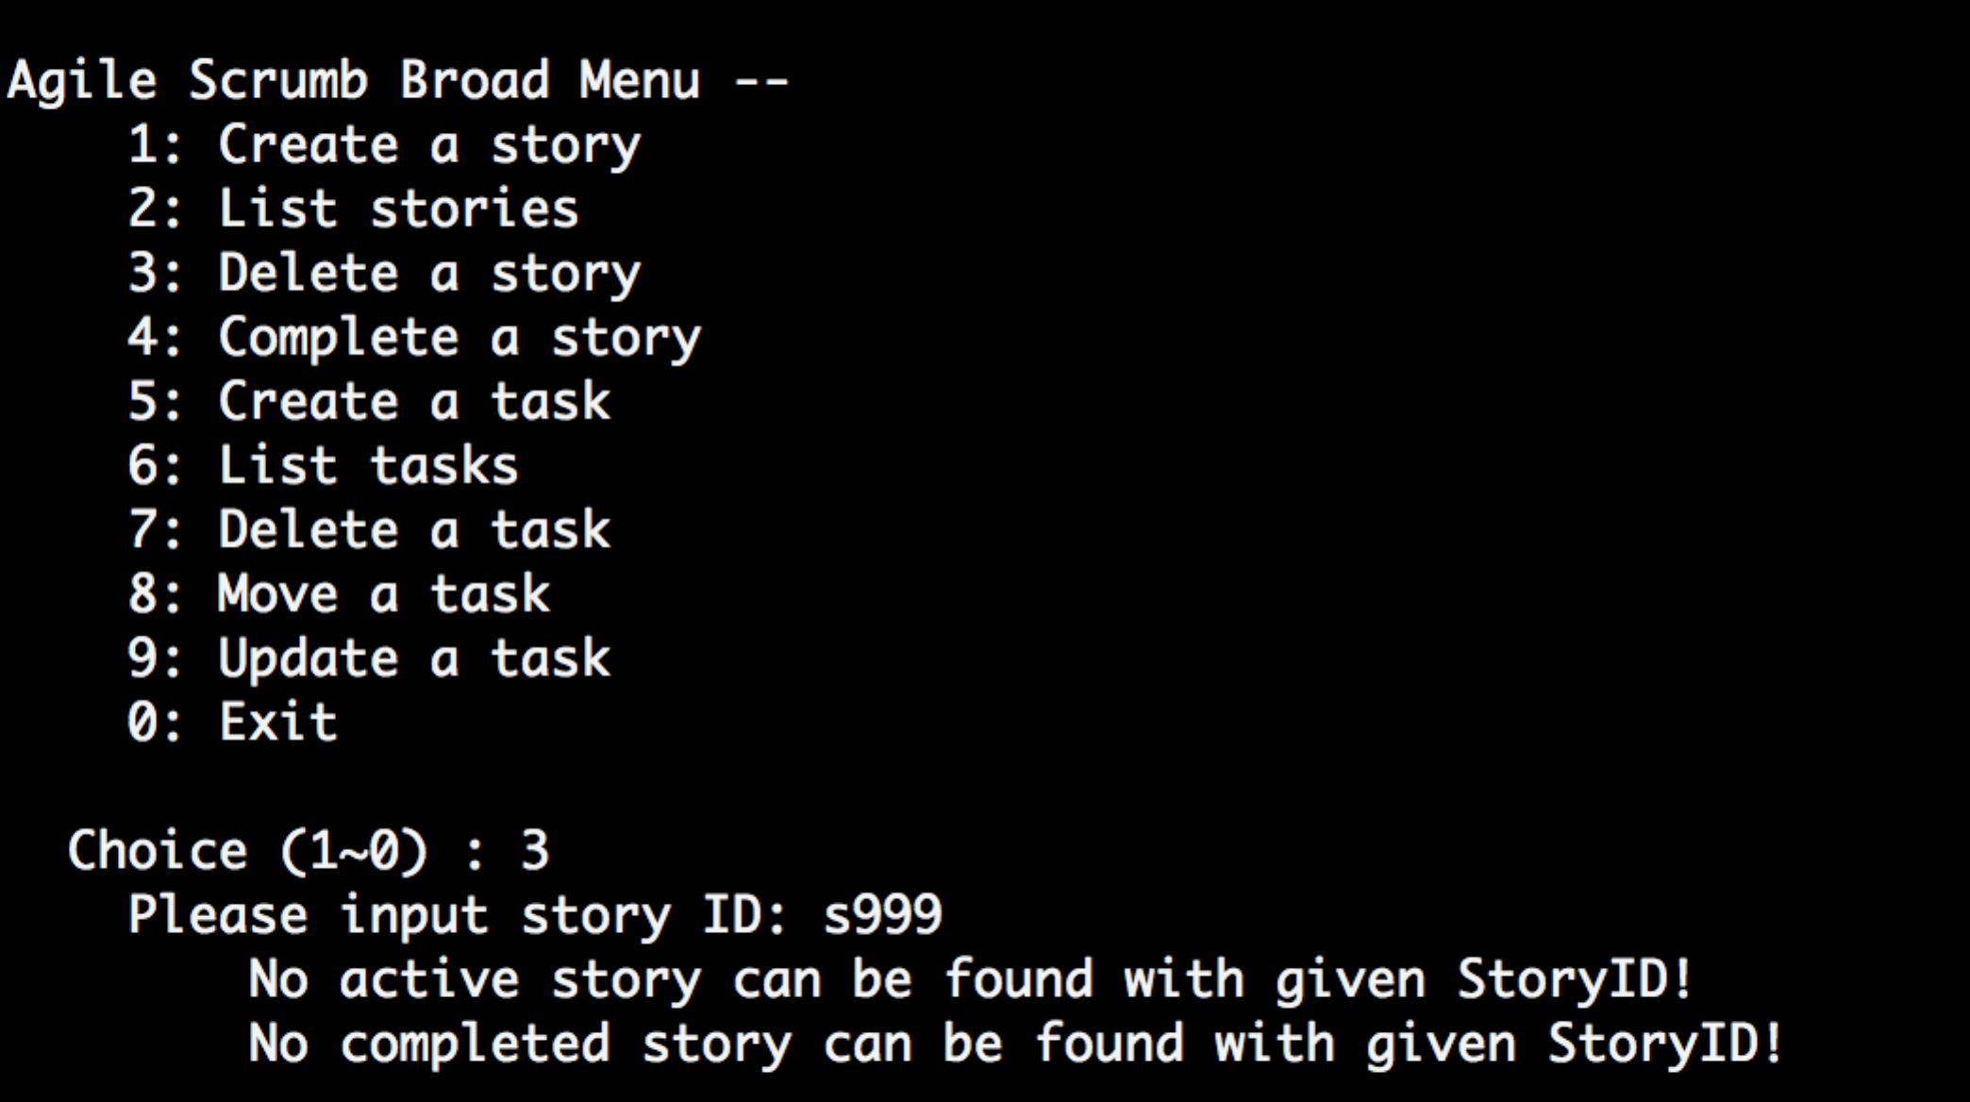

Test 3-2

Delete a completed story

The story is deleted and msg shows

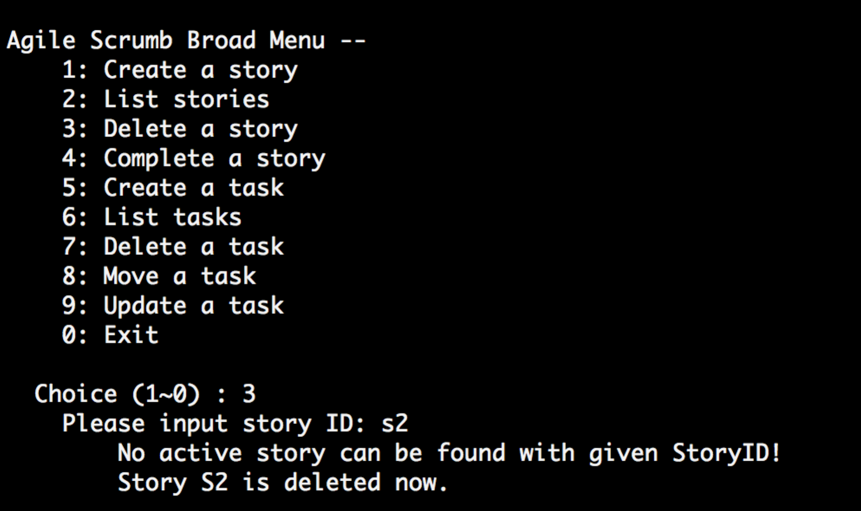

Test 4-0

Complete an active story with all completed tasks

The story is completed and msg shows

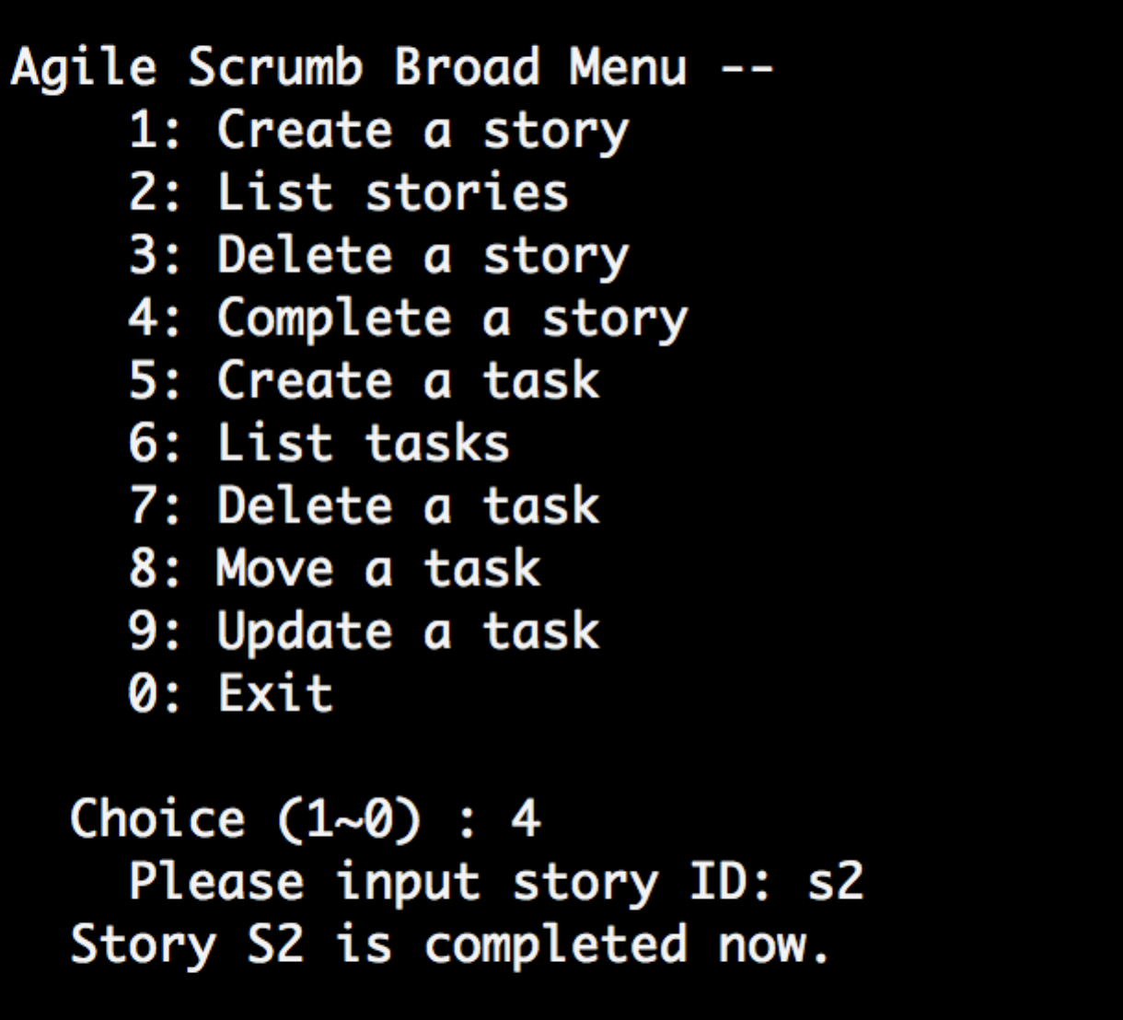

Test 4-1

Complete an active story with some incompleted tasks

The story is not completed and msg shows "tasks not completed yet"

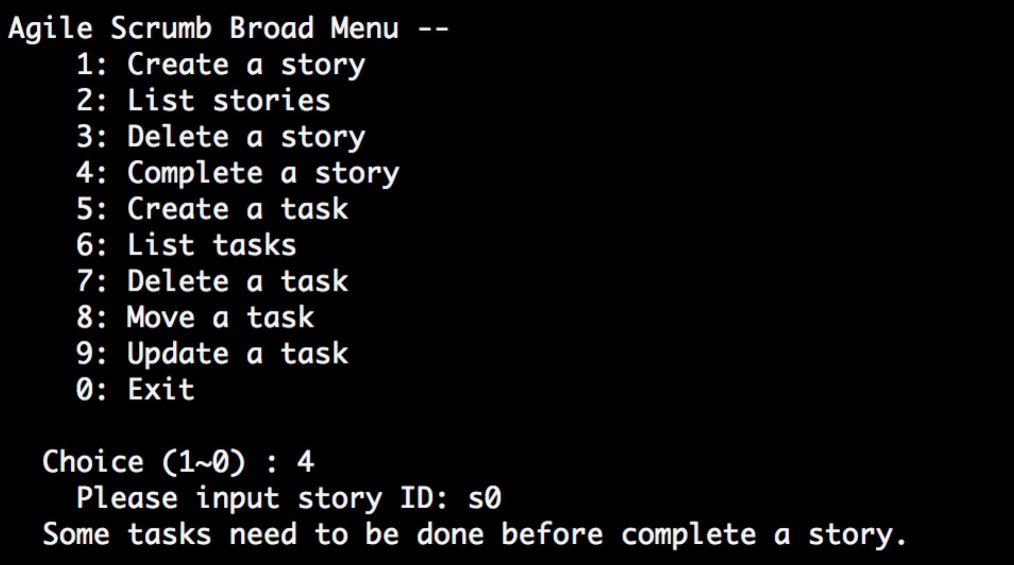

Test 4-2

Complete a completed story (s2)

The story is not completed and msg shows "No active story found"

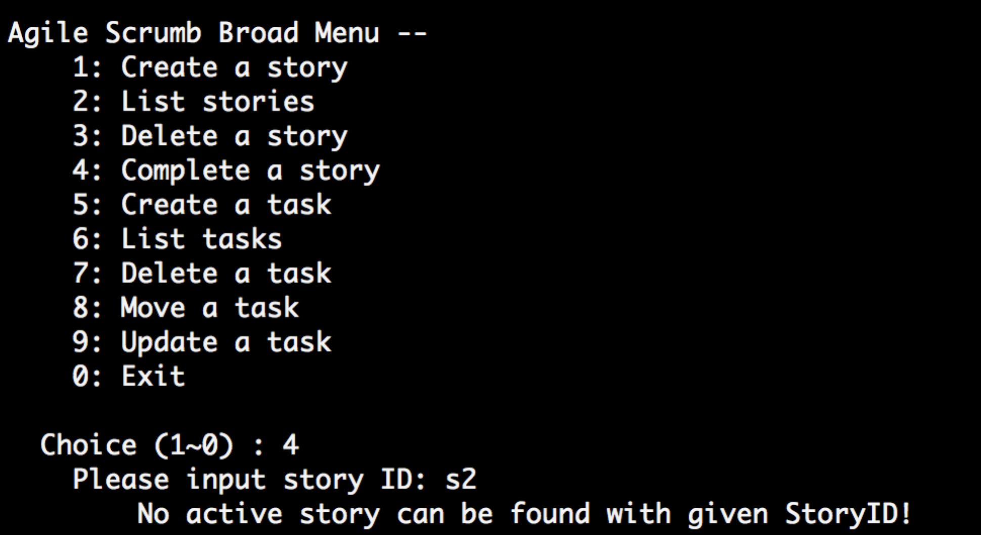

Test 5-0

create a task when no story is in the board

Warning msg shows no story yet

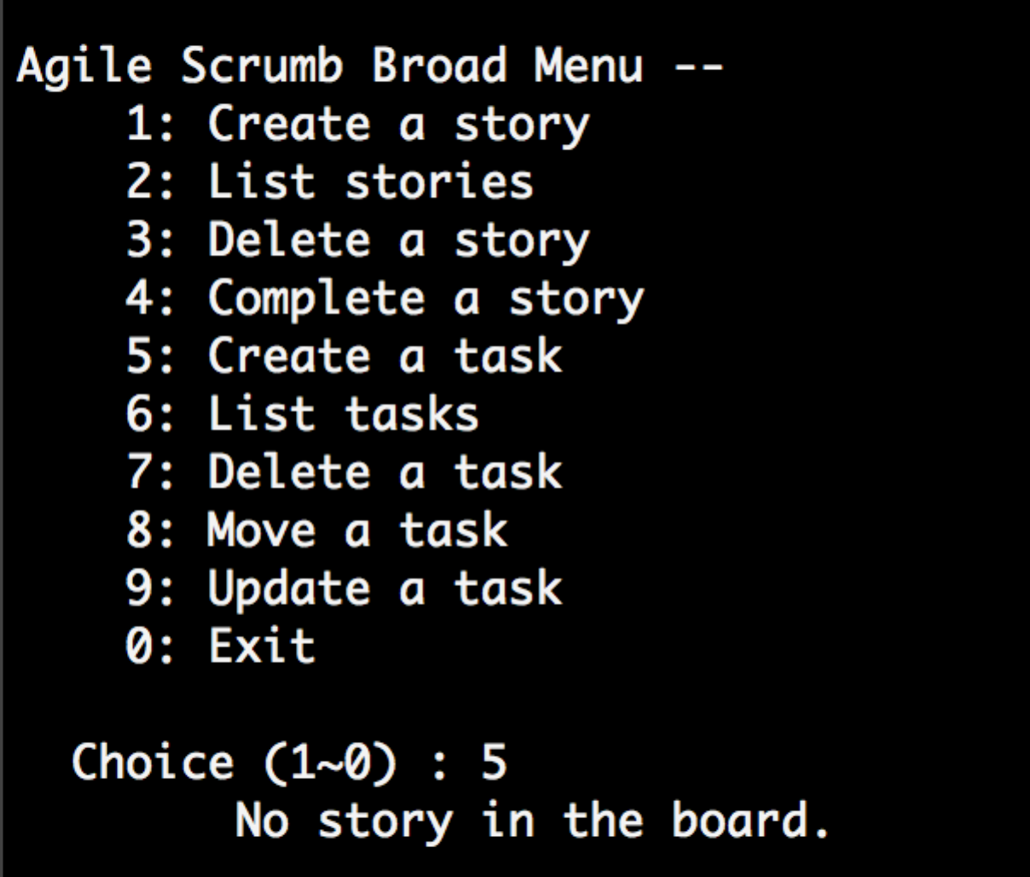

Test 5-1

create a task under an active storyID

a task is created and shows process successful

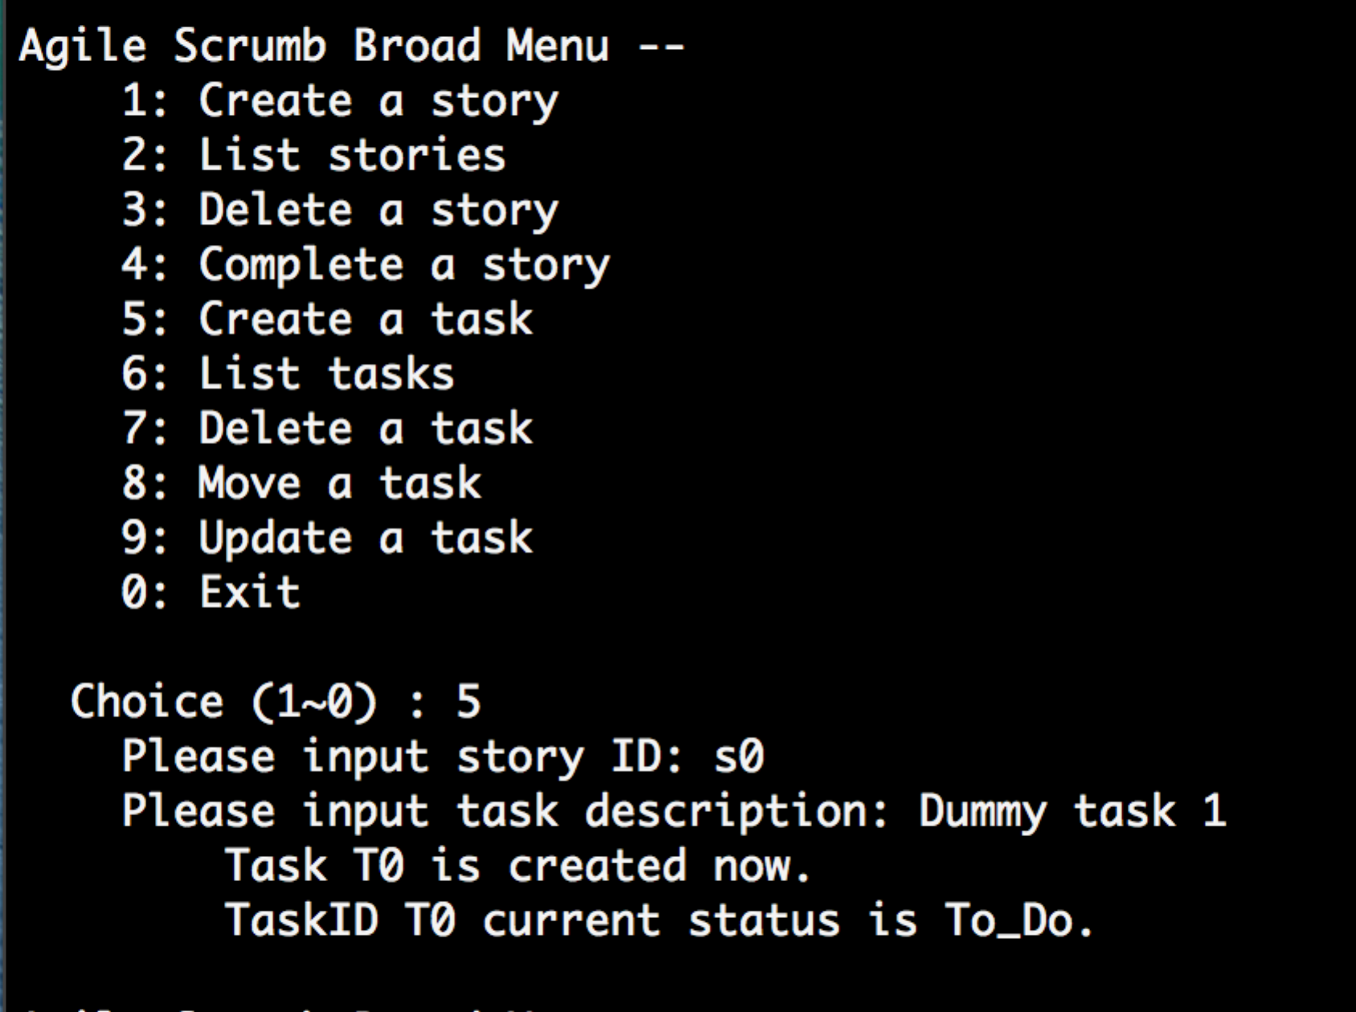

Test 5-2

create a task under a non-exist storyID

a task is not created and shows error msg "No story found"

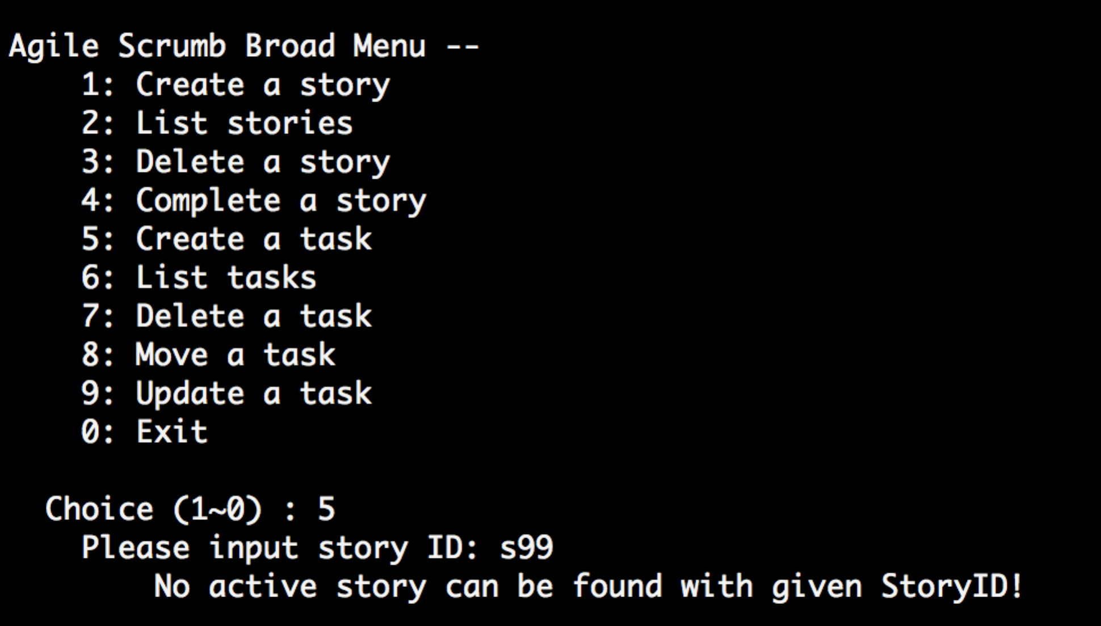

Test 5-3

create a task under a completed storyID

a task is not created and shows error msg

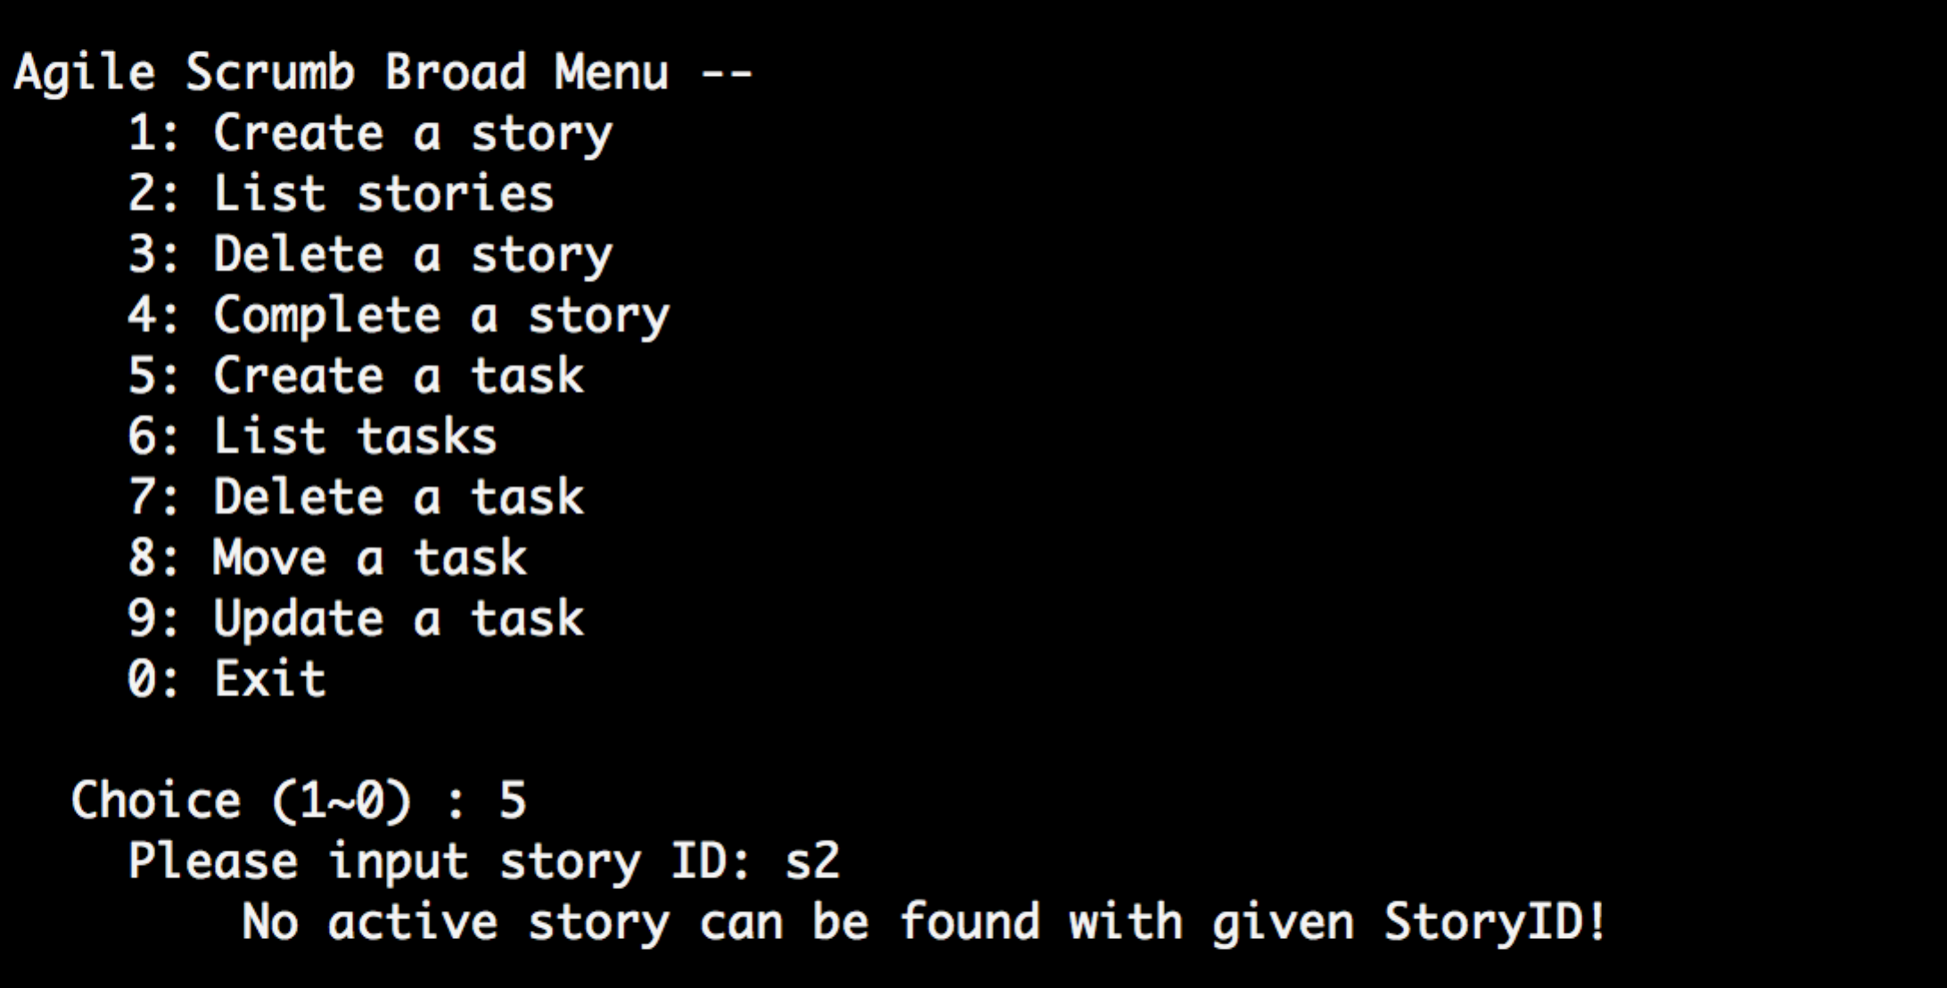

Test 6-0

list all task under the active storyID

all task should be listed

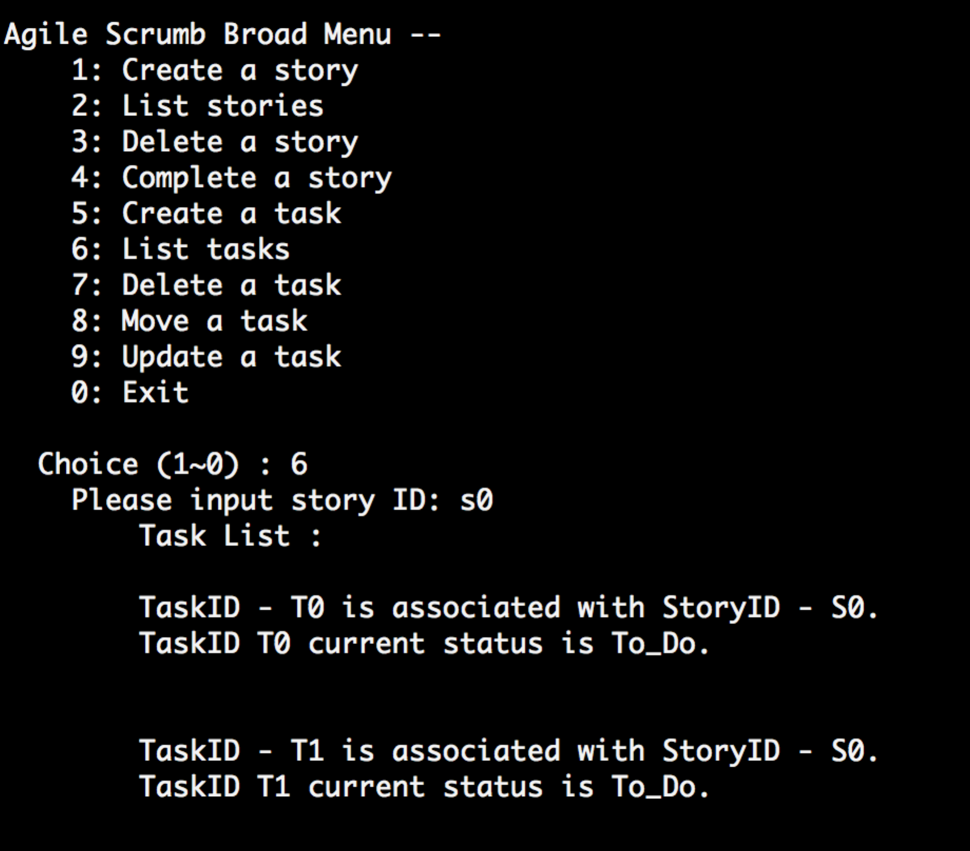

Test 6-1

list all task under the completed storyID

all task should be listed

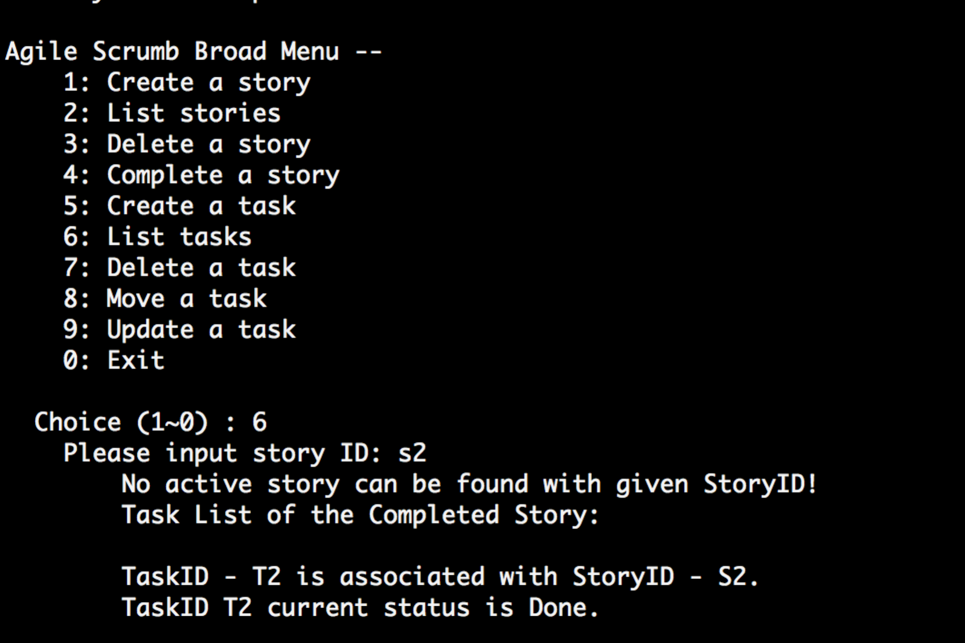

Test 7-0

Delete a task with incorrect storyID

Show error msg "The active story with the given ID cannot be found!"

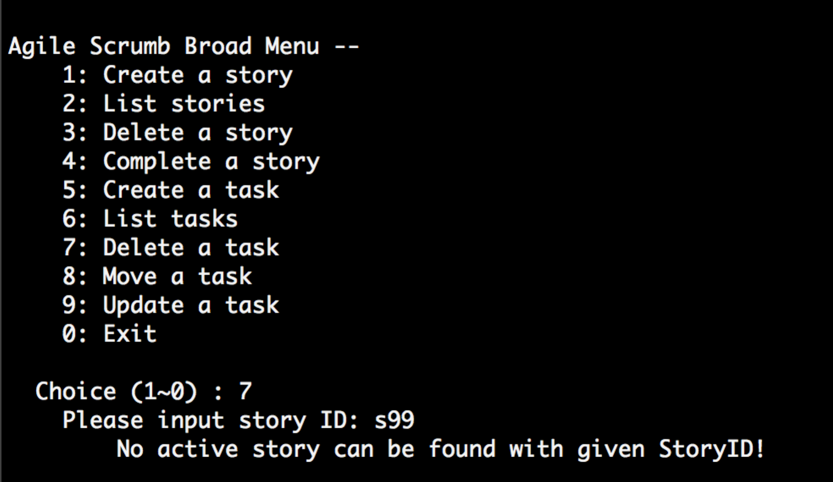

Test 7-1

Delete a task with completed storyID

Show error msg "The active story with the given ID cannot be found!"

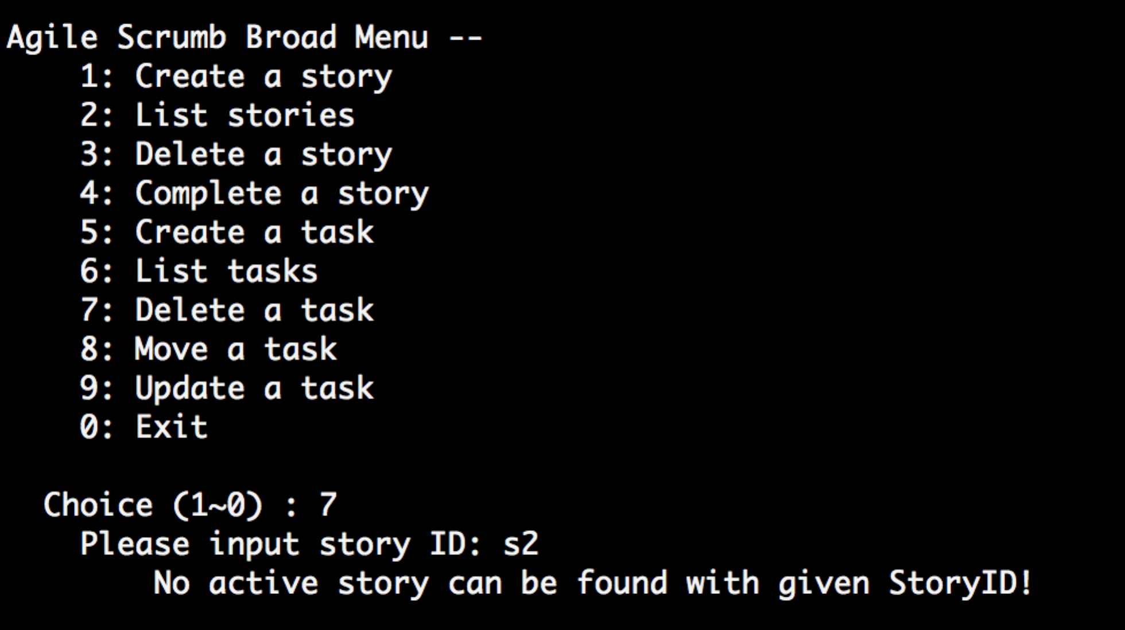

Test 7-2

Delete a task with active storyID but incorrect taskID

Show error msg "Task not found"

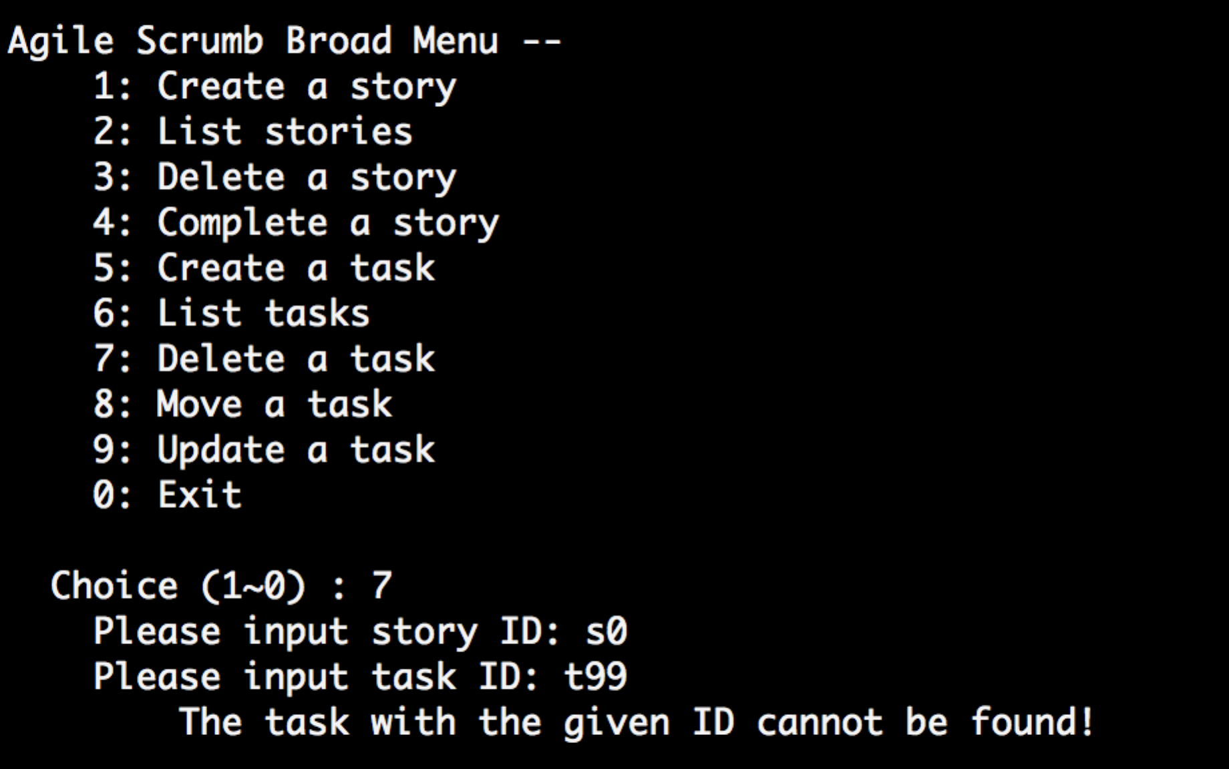

Test 7-3

Delete a task with correct storyID and taskID

task is deleted and msg shows

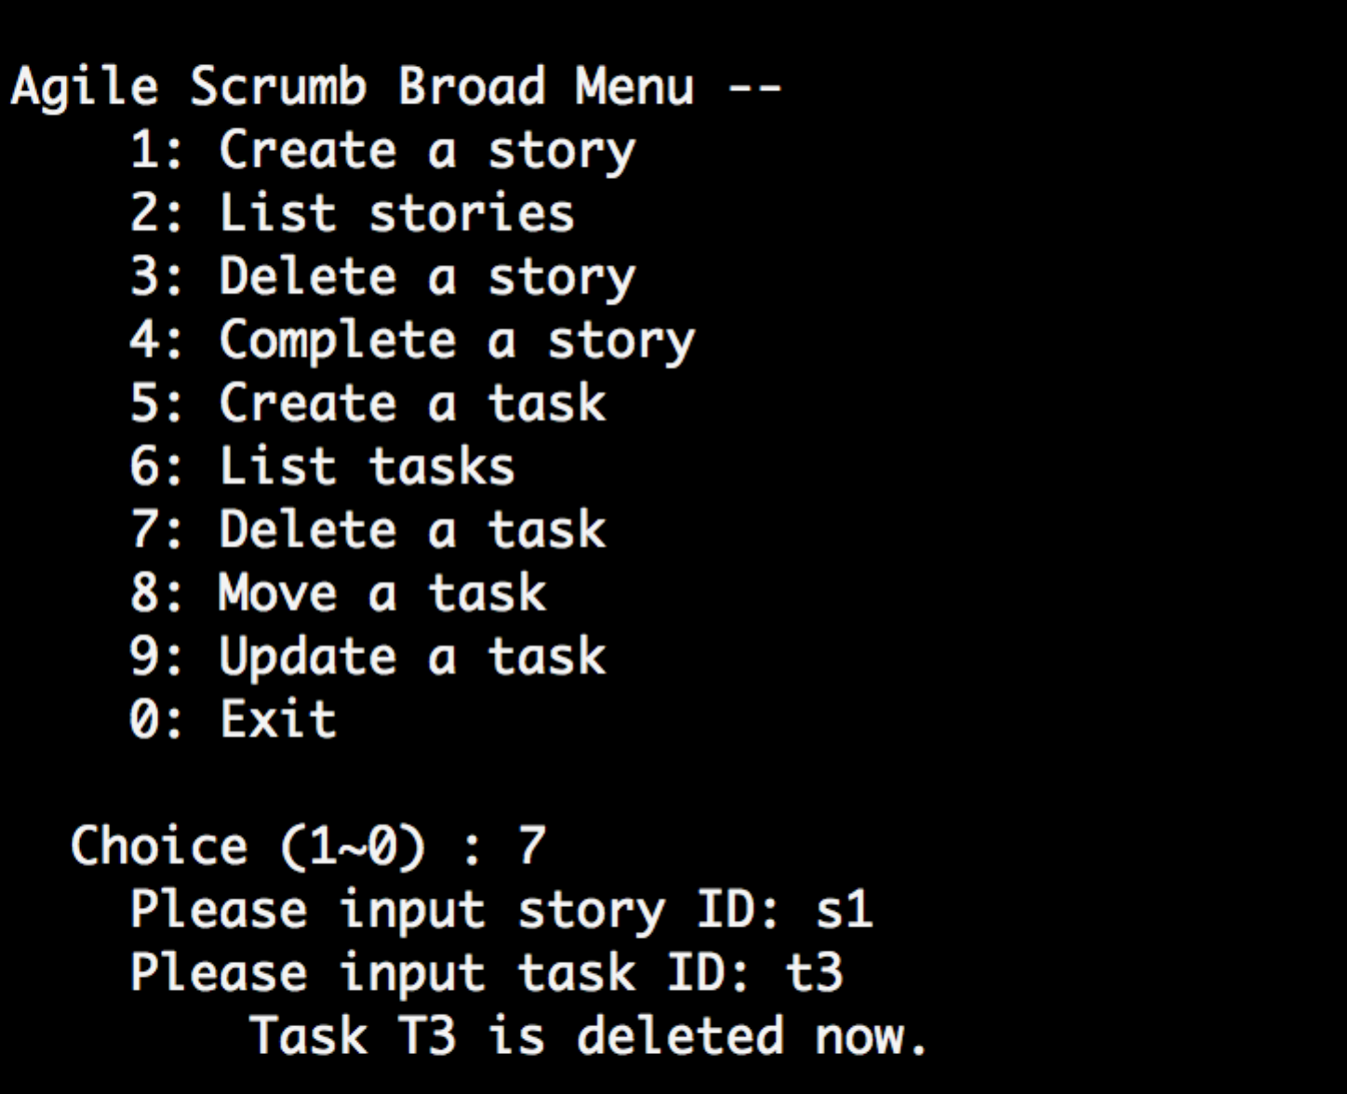

Test 8-0

move a valid task under the active storyID to a valid status

the task should be moved and msg shows

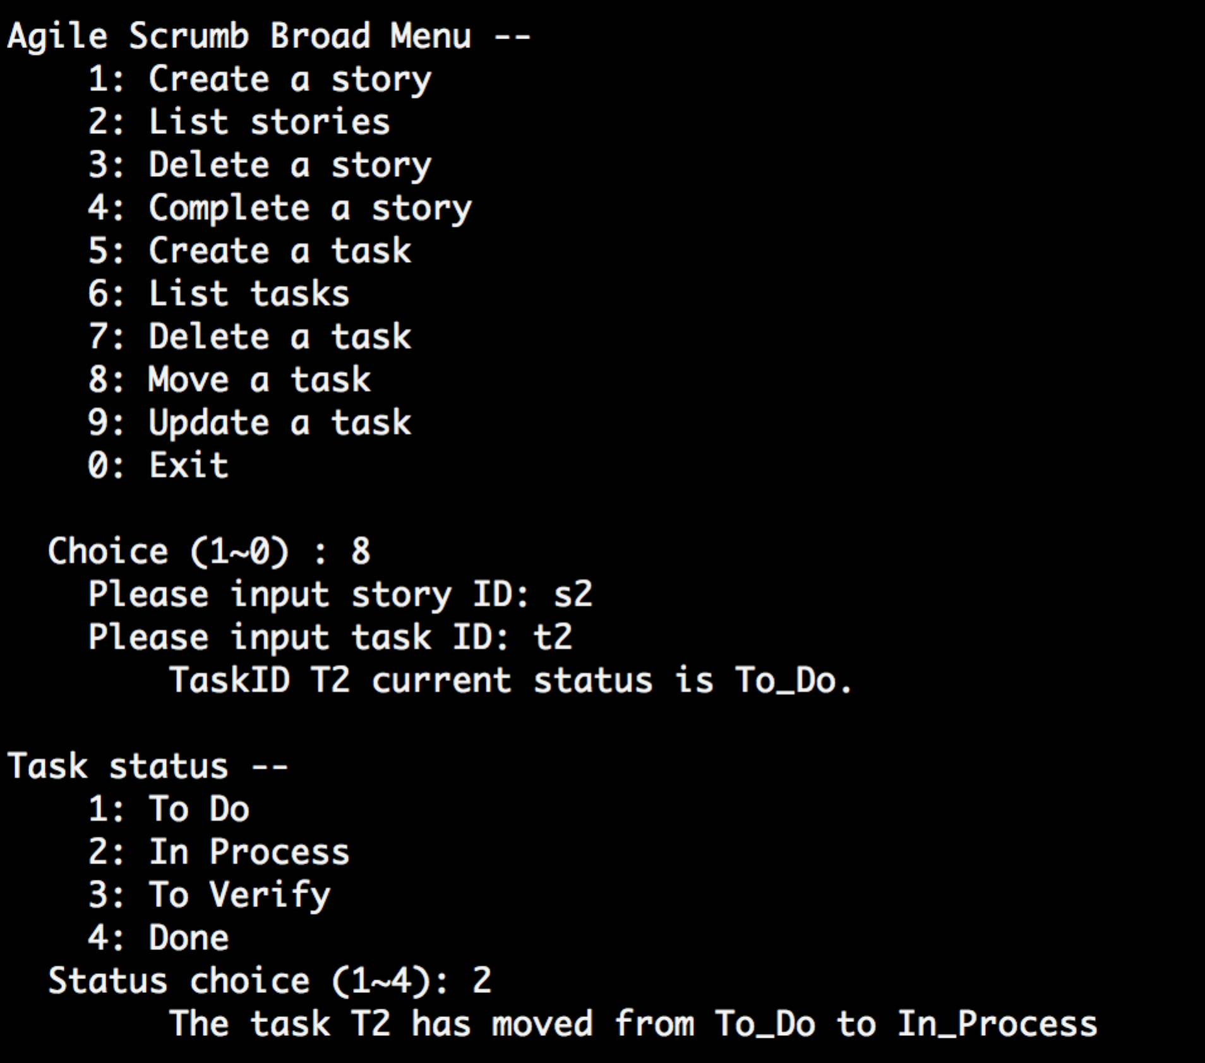

Test 8-1

move a invalid task under the active storyID

Show error msg "task not found"

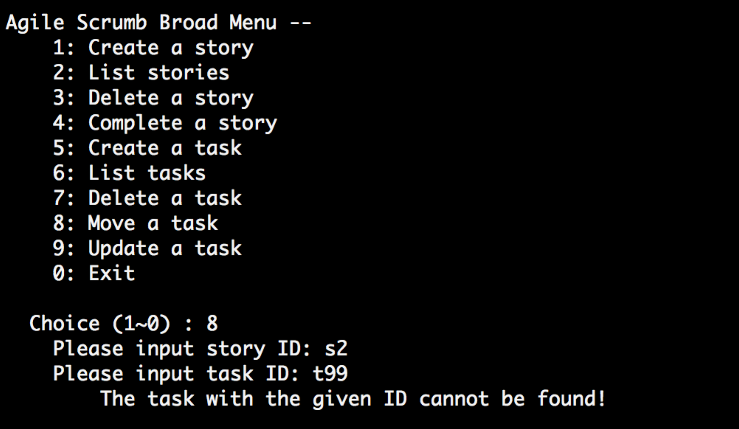

Test 8-2

move a valid task under the active storyID to from To_Do to Done

the task is not moved and msg shows "It's not a proper procedure to ..."

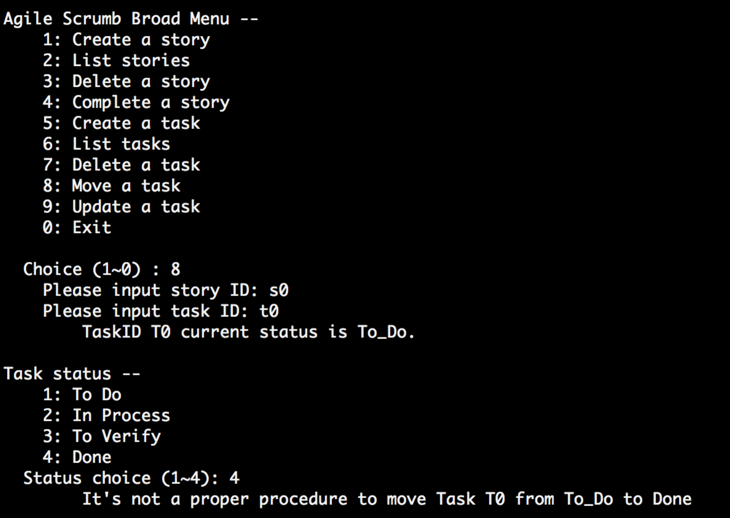

Test 8-3

move a valid task at the status of Done under the active storyID to other status

the task is not moved and msg shows "Task has been completed."

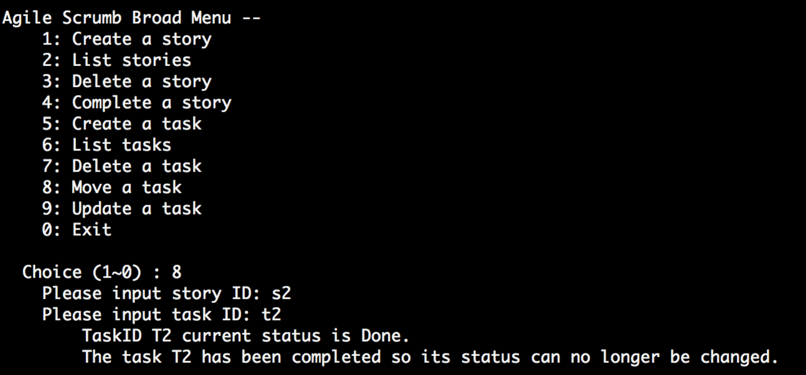

Test 9-0

Update a valid task under the active story with new description

task is updated and msg shows

Test 9-1

Update a valid task under the completed story

Show error msg "The active story with the given ID cannot be found!"

Test 9-2

Update a valid task under the active story with null description

Show error msg "The active story with the given ID cannot be found!"